DAY 24 – 14.05.2024 – OUTPUT SCREENSHOTS

1. TO GET ALL DOCTORS

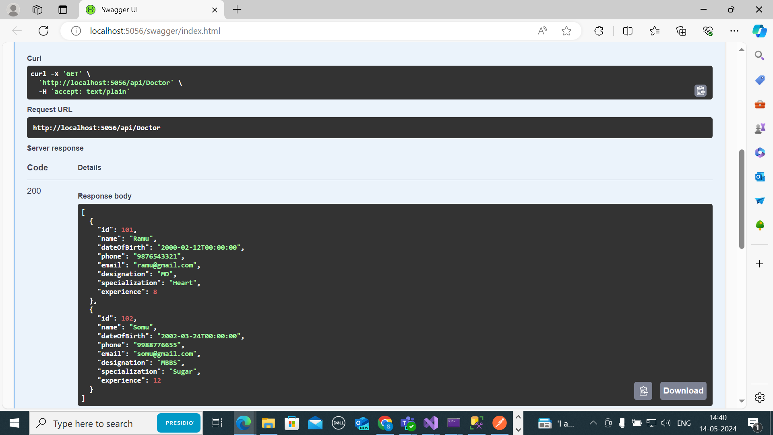

1. TO UPDATE EXPERIENCE OF A DOCTOR

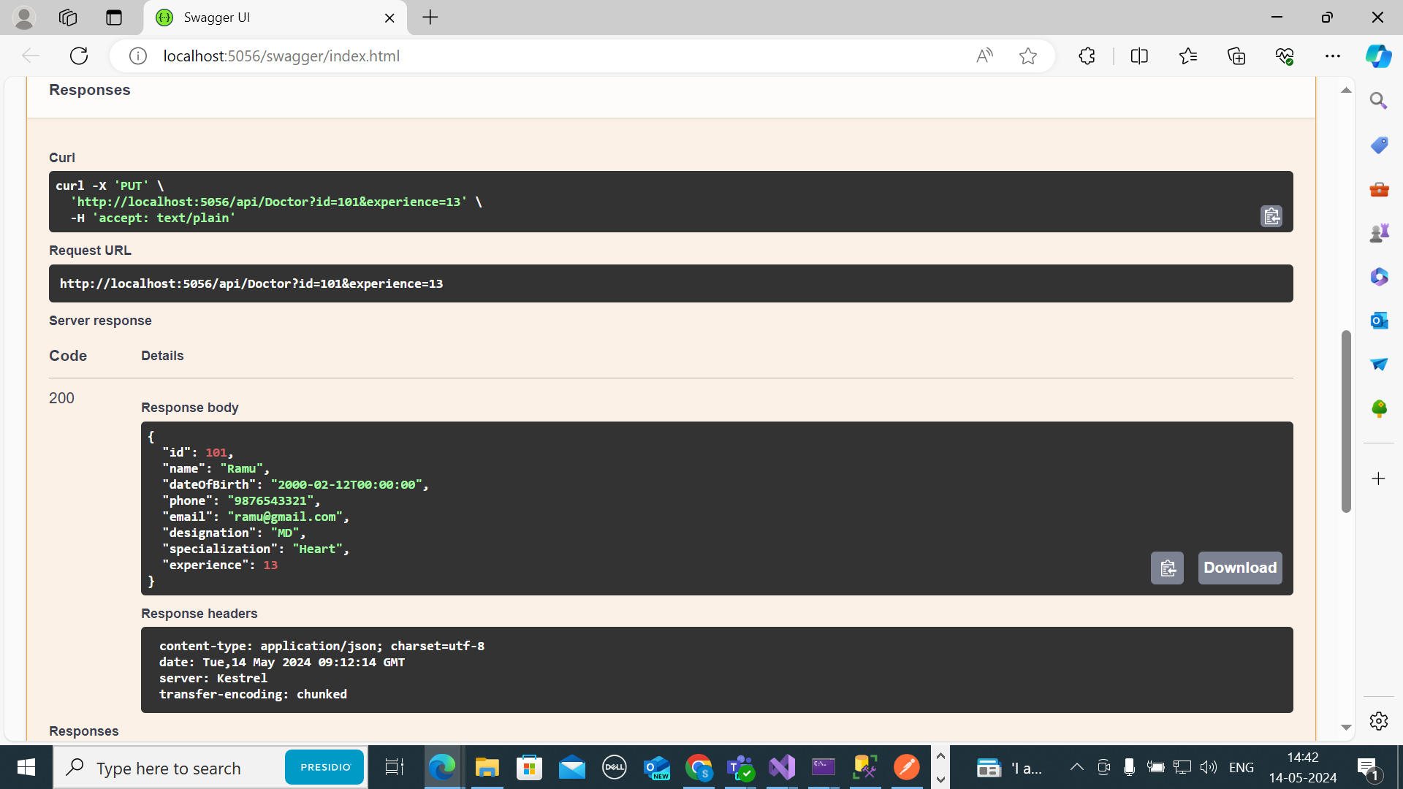

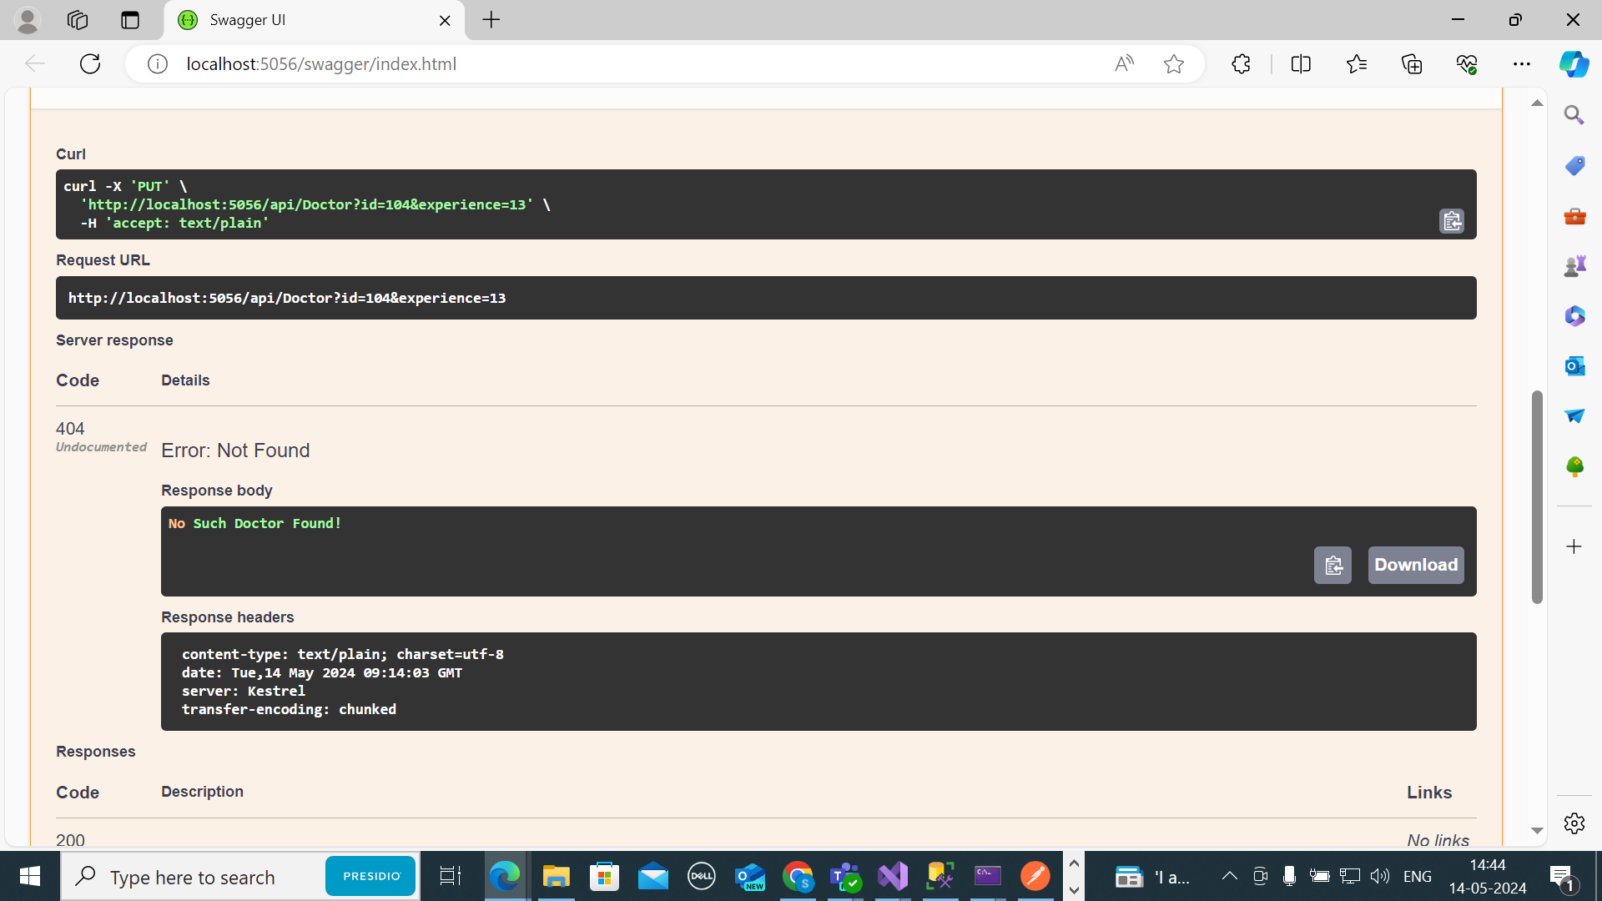

1. TO GET DOCTORS BASED ON SPECIALIZATION

